Creating user and password
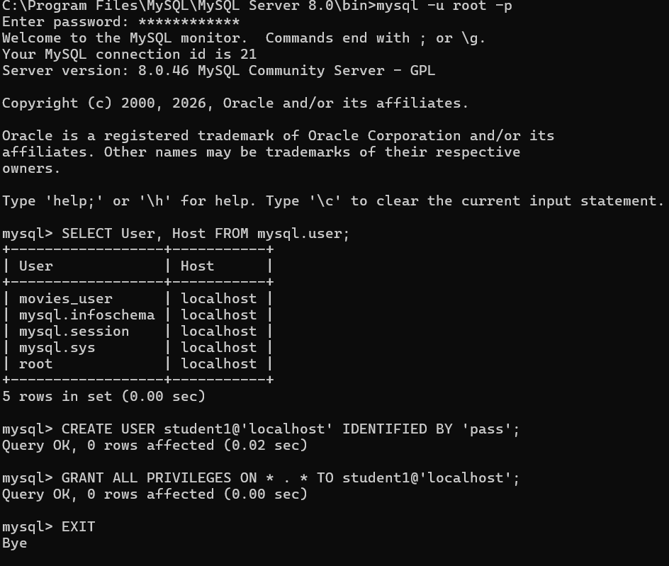
Creating databasedb and table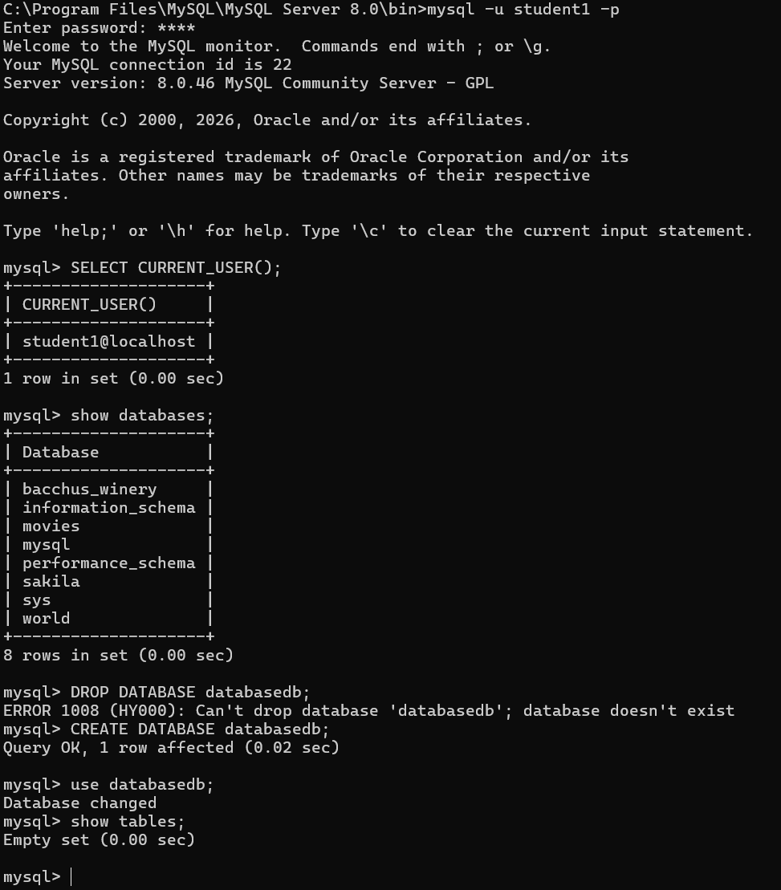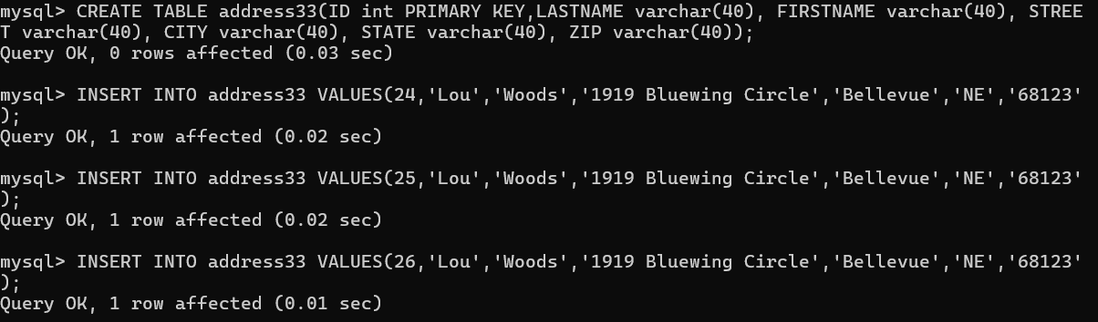
Testing java connection through CreateTable.java
